39.Write a Pandas program to get the first 3 rows of a given DataFrame.
Aim:
To write a Pandas program to get and display the first 3 rows of a given DataFrame.
Program:
import pandas as pd

data = {
'Name': ['Raj', 'Ravi', 'Sita', 'Anu', 'Kiran'],
'Age': [20, 21, 19, 22, 20],
'Marks': [85, 90, 88, 92, 80]
}

df = pd.DataFrame(data)

print("First 3 rows of the DataFrame:")
print(df.head(3))
Output:
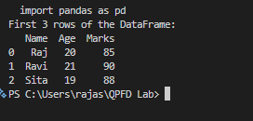
Result:
Thus, the Pandas program to display the first 3 rows of a given DataFrame was successfully executed.

40.Write a Pandas program to select the name and score columns from the given DataFrame.

Aim:
To write a Pandas program to select the Name and Score columns from a given DataFrame.
Program:
import pandas as pd

data = {
'Name': ['Raj', 'Ravi', 'Sita', 'Anu'],
'Age': [20, 21, 19, 22],
'Score': [85, 90, 88, 92]
}

df = pd.DataFrame(data)

print("Name and Score columns:")
print(df[['Name', 'Score']])
Output:
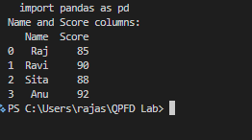
Result:
Thus, the Pandas program to select and display the Name and Score columns from the DataFrame was successfully executed.

